ADVANCED PYTHON PROGRAMMING

NAME : Sathish V

REG NO : 22MID0160

ERRORS:

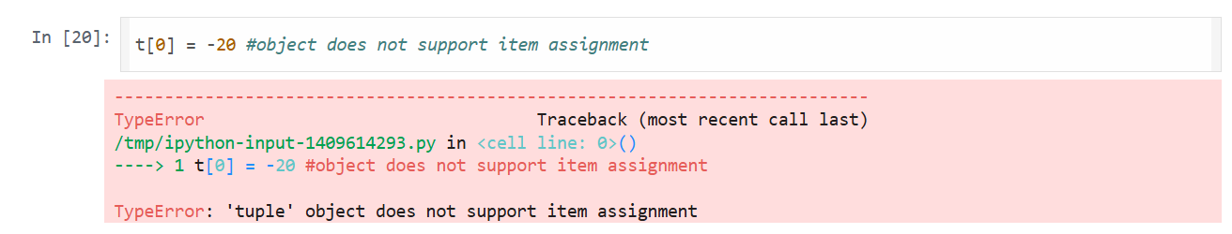

ERROR: Object not support item assignment

Solution : Tuple is Immutable